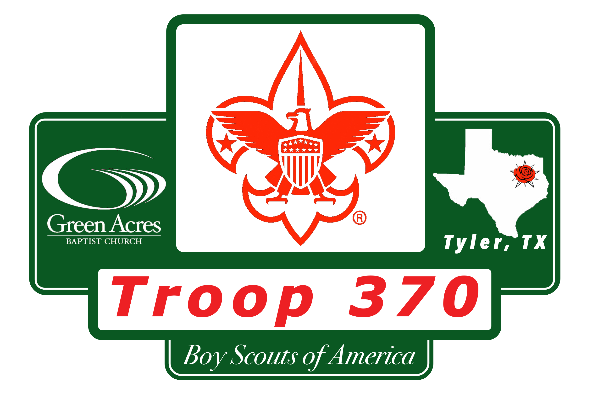

Monthly Campout Checklist

This checklist is for our monthly campouts to help remind you of the “standard” items that should be considered for each campout. Some of these are weather specific but remember rain gear is always appropriate!
Field Uniform is appropriate with a Troop Activity Shirt (T-shirt) worn underneath.
We always travel to and from camp in uniform.
Bring A “sack supper” for Friday night unless otherwise specified.

Remember it’s the Scout motto to “Be Prepared”.

Use the “blank” items to add anything that is specific to the event or for you.
 | Description | Comments | Check
1. | Backpack (bag or tote) to pack items
2. | Sleeping Bag and pad (air mattress)
3. | Rain gear
4. | Personal hygiene (tooth brush, etc.)
5. | Personal first aid kit
6. | Extra clothes (pants, shirt, socks, underwear, warm clothes as needed)
7. | Extra shoes (NO OPEN TOE SHOES)
8. | Water bottle (1L or 32oz minimum)
9. | Eating (Plate, cup, spoon, fork)
10. | Flashlight
11. | Compass
12. | Fire starter (matches, lighter, striker)
13. | Bible (optional)
14. | Snacks (optional)
15. | Chair (optional)

