Troop 39 Black Canyon Paddle Outing - November 10-12, 2018

What: | Two night canoe/kayak trip through Black Canyon on the Colorado River from Willow Beach. Upstream to Arizona Hot Springs and Boy Scout Hot Springs.
When: | Saturday to Monday, Nov. 10 to 12, 2018. Meet at FCF Saturday at 5:45 AM, depart at 6:00 AM. We will have breakfast in Kingman on the way there and dinner on the way back. We will return to FCF Monday between 5 and 8PM.
Where: | Black Canyon between Hoover Dam and Willow Beach, 11 miles below the dam. Travel time is about 3 hours from Flagstaff. Saturday night we will camp at the Arizona Hot Springs beach (~4 miles below the dam) and Sunday night we will Camp at Boy Scout Hot Springs Beach (~3 miles below the dam). See the maps below.
Who: | Adults & Scouts who have met the following requirements:  - Have a current (< 1 year old) BSA Health form part A & B and no medical conditions that may compromise safety.  - To have a one person boat or to sit in the rear of a two person, you must be an adult or a big/strong scout, you must be proficient at maneuvering a paddle craft and be able to recover from a capsize.  - All scouts must have a parent/guardian signed Activity Consent form (print from Trooptrack)
Other: | - Cost: $20 for meals in Kingman, $10 for gas  - Everyone must wear a life jacket and foot-wear (attaches to the feet) while on the river  - Cell phones may not have a signal in Black Canyon  - Pack all gear in backpacks and then in dry bag if you have one.

What to bring:
- Dry bag or day pack in 2 plastic bags  - Sleeping bag in dry bag or 2 plastic bags & pad  - Tent*  - Food (2 breakfast, 3 no cook lunches, 2 dinner, and snacks)*  - Water (2 quarts and means of purifying* lake/river water)  - Mess kit | - Backpacking stove, fuel and cookware (if cooking)*  - Sunscreen (important!)  - Flashlight  - Pocket knife (& totin’ chip)  - Toiletries  - Medications  - Small first aid kit  - Water/short hike shoes (wet)  - Camp shoes (dry)  - Swimsuit (paddle shorts) | - Shorts/pants Class B or river shirt  - Rain coat or poncho  - Sweatshirt or light coat  - Hat  - Sleepwear  - Camera (in dry bag or disposable)  - ~$20 for 2 fast food meals and a soft drink at the marina  - Whistle (optional)  - Fishing gear & license (optional)
* Items that can be shared within patrols or between scouts if coordinated in advance
Canoe Assignments (front to back):
Canoe #1: Abe, Griffin, Skyler
Canoe #2: Caleb, Bailey, Tristyn
Canoe #3: Conor, Alex, Avery
Canoe #4: Daniel, Christopher, Don
Canoe #5: Cohen, Christian, Preston
Canoe #6: Lucas, Bill
Canoe #7: Anthony, Anthony
Canoe #8: Jeff
Kayak #1 (Point): Sean
Kayak #2 (Sweep): Grady
Getting to the Willow Beach Marina on Saturday 11-10-18:
207 miles, 3 hours according to Google Maps. We will stop in Kingman for Breakfast. From Milton Rd. & Rt. 66, take Rt. 66 W. ~ 4 miles to I-40, go W. on I-40 ~ 139 miles to Kingman. After breakfast, get back on I-40 and go W. ~ 3 miles to exit 48 for US-93 N. toward Las Vegas, go N. on US-93 ~ 56.5 miles, to Willow Beach Road, turn left and follow Willow Beach Road to the Willow Beach Marina.

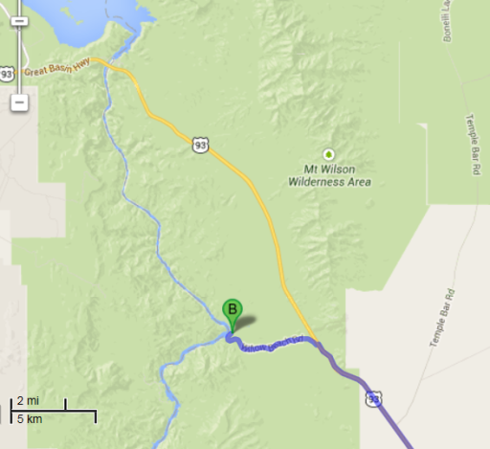
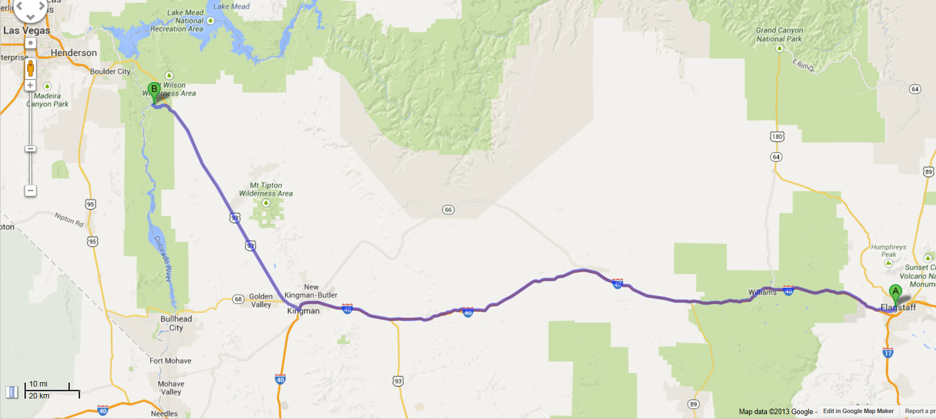
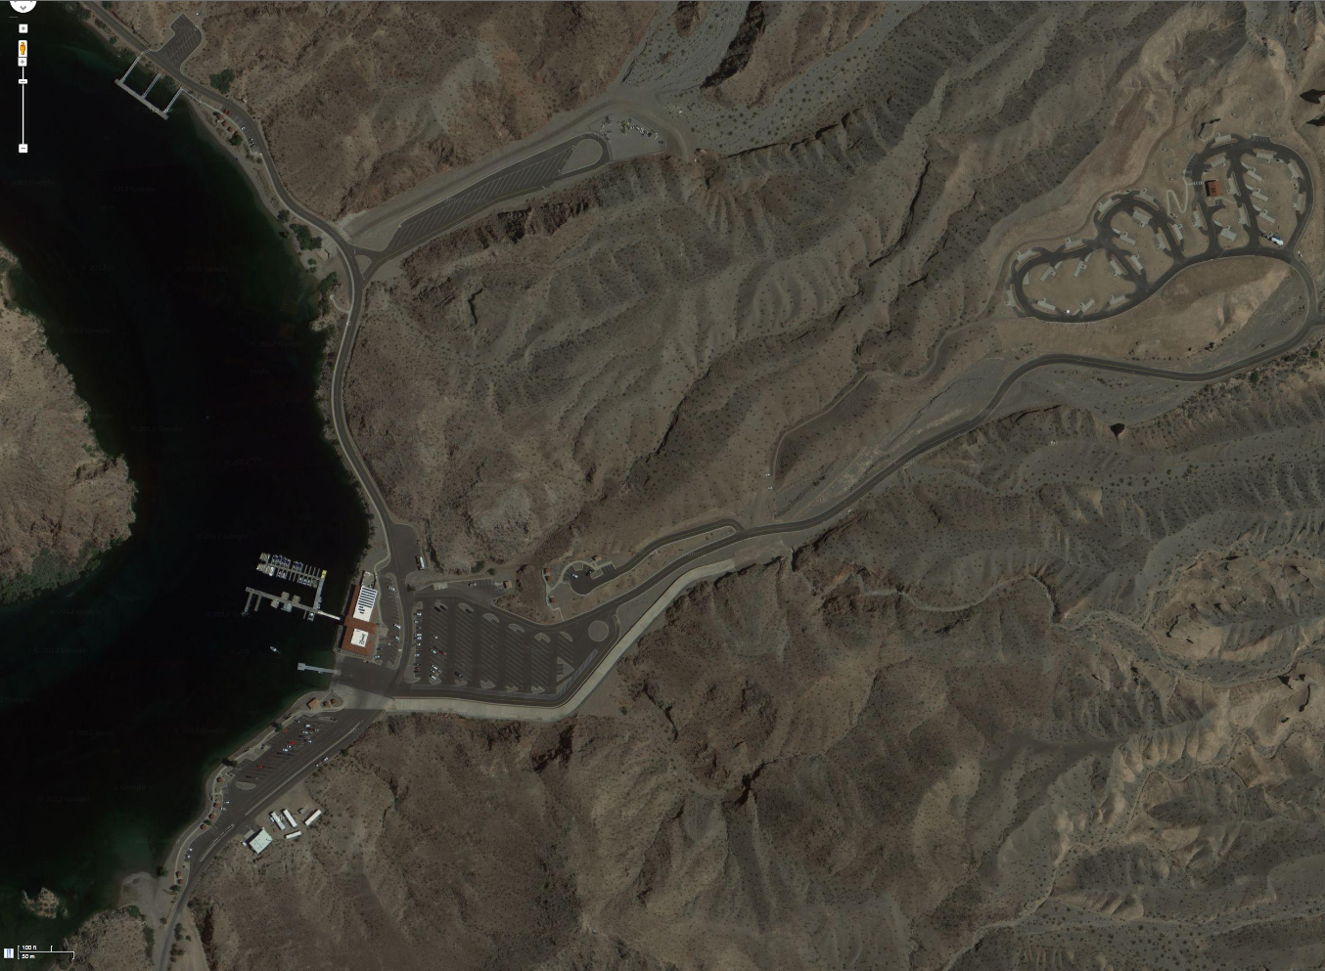
Put in & Takeout
Beach
Marina & Store
Campground

