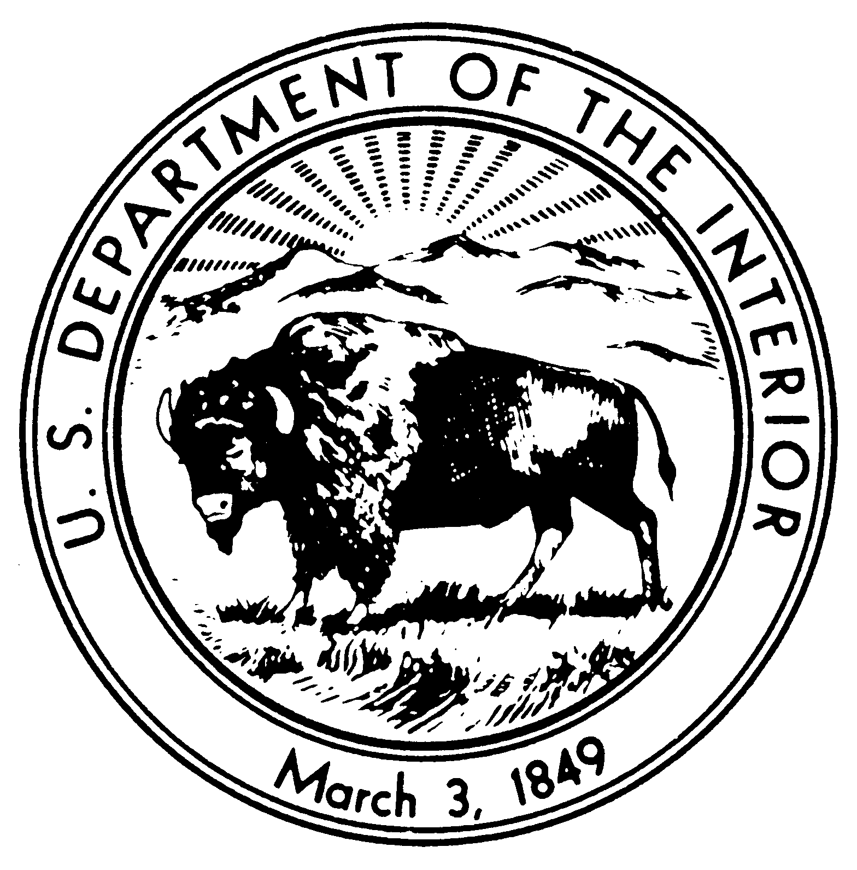
United States Department of the Interior
NATIONAL PARK SERVICE
Thomas Edison National Historical Park
211 Main Street
West Orange, New Jersey 07052-4948
IN REPLY REFER TO:

March 22, 2019

Dear Pack 142:

This letter confirms your group’s reservation to visit the Thomas Edison National Historical Park. Please print this letter and bring it with you on the day of your visit.

Group Name: Pack 142 | Program reserved: Invention Factory & Jr. Ranger
Date of Visit: Saturday, May 18, 2019 | Maximum number of people in group: 30
Time of Visit: 10:00 | Payment due: $15.00 anyone 16 and over

You must first stop at the Laboratory Complex Visitor Center to check-in and pay the entrance fee of $15 for all visitors 16 and over. We are able to accept payments by cash or credit card. For your convenience, only the group leader needs to meet with the Ranger in the Visitor Center to pay the fee and obtain orientation information, unless someone in the group is using a National Park Pass.

Please arrive at the Visitor Center no later than 10:00 am to give yourself enough time to be at the start of your 10:00 am tour.

There is bus parking available in the visitor parking lot across from the Laboratory Complex. Make sure to use the crosswalks when crossing Main Street.

There are no eating facilities or picnic areas at the Laboratory Complex. However, there are several restaurants and picnic sites located in West Orange. Most local restaurants require reservations for groups.

If you need to cancel the day of the program, or you are running late, please call the Laboratory Visitor Center at 973-736-0550 ext. 11. In case of severe weather, information about delayed opening or park closure will be posted on this line by 7:00 am.

Thomas Edison National Historical Park is located at 211 Main Street, West Orange, NJ 07052. Directions can be obtained from the park’s website at: http://www.nps.gov/edis/planyourvisit/directions.htm.

If you have any further questions, the group reservations coordinator can be reached at shemaine_mckelvin@nps.gov or 973-736-0550, ext. 33. The reservation office is closed on Mondays and Tuesdays; all messages will be returned as soon as possible.

Your itinerary: (Invention Factory/Junior Ranger Program)
Arrive
Meet ranger in courtyard entrance
Introduction to Laboratory Complex from Ranger
1 Hour Ranger Led Guided Tour of the Main Laboratory Complex Building 5
Take the Jr. Ranger Pledge and receive a Jr. Ranger Badge and Patch
Conclusion and Movie “The Invention Factory” shown in the Visitors Center

All the best,

Shemaine Mckelvin
Group Tour Coordinator

